**Use Dashboard Nodes for Creating UI (Web Apps)**

|  |  |
| --- | --- |
| Team ID | PNT2022TMID29275 |
| Project Name | Smart waste management system for  metropolitan cities |

Step 1: Open Node red and pick and place blocks according to python script flow

Step2: Make sure necessary blocks are installed in Node Red Step 3: After creating the flow click on deploy

Step 4: Output is displayed in Node-red Debug window

Step 5: Also, web UI can also be seen by the URL followed by/ui

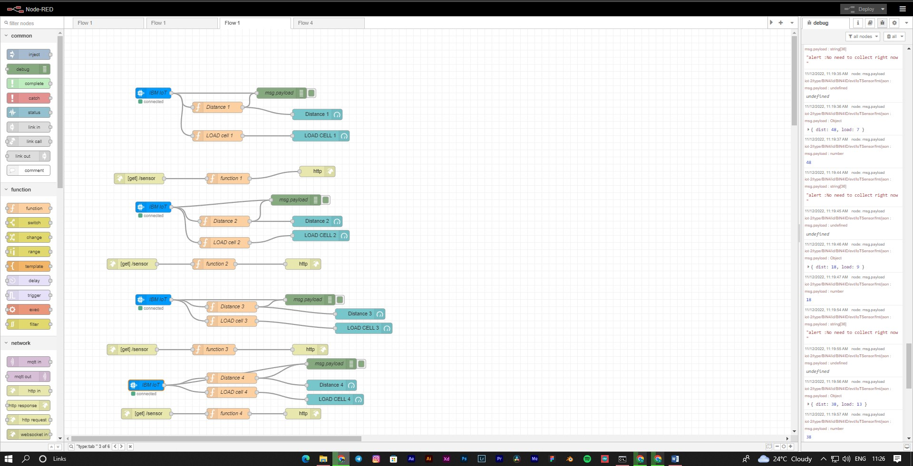**Screenshots: NODE – RED FLOW**

**NODE – RED UI**

